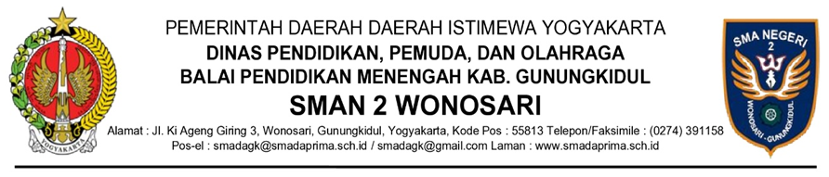
NAMA JABATAN
KEPUTUSAN ……………………
NOMOR ........ TAHUN...........
TENTANG
..........................................................
NAMA JABATAN,

Menimbang | : | a. bahwa ..............................................................................;
 |  | b. bahwa ..............................................................................;
Mengingat | : | - ........................................................................................;
 |  | - ........................................................................................;

MEMUTUSKAN:

Menetapkan | : | KEPUTUSAN ........... TENTANG ............................................
 |  | .............................................................................................
KESATU | : | .............................................................................................
KEDUA | : | .............................................................................................

Ditetapkan di ......................
Pada tanggal .......................

KEPALA SMAN 2 WONOSARI,

(Tanda Tangan dan Cap Jabatan)

TIYA

